Real-time forecast service for geomagnetically induced currents

Technical proposal

In response to Announcement of Opportunity AO/1-4246/02/NL/LvH
Pilot Project for Space Weather Applications
Study manager: | Henrik Lundstedt
Project manager: | Peter Wintoft
Administrative manager: | Lars Eliasson

Table of contents
1 Summary 3
2 Abbreviations 3
3 Introduction 3
4 Main problems 5
5 Proposed solution 6
5.1 GIC forecast service 6
5.2 GIC forecast model 6
5.2.1 GIC data 7
5.2.2 Solar wind data 8
5.2.3 Computed geomagnetic data in south Sweden 8
5.2.4 Neural network model of dB/dt 8
5.2.5 The horizontal geoelectric field 9
5.2.6 Using forecasted geomagnetic field 10
5.2.7 Direct forecasting of GIC 10
5.2.8 Model validation 11
5.3 Service implementation 11
5.3.1 Real-time data 11
5.3.2 Models 12
5.3.3 User interface 12
6 Work plan 13
7 Application perspectives 13
8 References 14

Summary
This document address the technical issues of the application Rea- time forecast service for geomagnetically induced currents in response to the ESTEC AO/1-4246/02/NL/LvH – Pilot Project for Space Weather Applications.
The goal of the project is to develop a forecast service to be used by electrical power companies to mitigate the effects of geomagnetically induced currents caused by the space weather. For this purpose Swedish power companies have been identified as service users and shall take active part in the project. The service developer and provider is the Swedish Institute of Space Physics in collaboration with the Finnish Meteorological Institute.
The project shall result in a software package implementing a prototype service, and a cost-benefit analysis of the service. The service shall also be coordinated with the Space Weather European Network (SWENET).

Abbreviations
In this document the following abbreviations are used:
ACE | Advanced Composition Explorer
ESA | European Space Agency
FMI | Finnish Meteorological Institute
GIC | Geomagnetically induced current
IMAGE | International Monitor for Auroral Geomagnetic Effects
IRF | Swedish Institute of Space Physics
IRF-K | Swedish Institute of Space Physics, Kiruna
IRF-L | Swedish Institute of Space Physics, Lund

Introduction
Space Weather refers to “Conditions on the sun and in the solar wind, magnetosphere, ionosphere, and thermosphere that can influence the performance and reliability of space-borne and ground-based technological systems and can endanger human life or health”.
When a coronal mass ejection (CME), a huge plasma cloud, hits the Earth, electrons in the Earth’s magnetosphere cascade into the polar regions, creating a current that flows along the auroral oval. The magnetic field from this current induces a geomagnetically induced current (GIC) that can damage transformers and shut down power grid systems.
GICs have been recorded by the power industry during many years. The first documented case, occurred on Easter Sunday, March 24, 1940. On the US East coast many disturbances were noted on March 24, such as reactive power disturbances and misoperating relays. A severe geomagnetic storm was the cause and the Ap index reached 207. The most spectacular solar-terrestrial event took place in March 1989. The entire province of Quebec experienced a blackout lasting about nine hours. The Hydro-Quebec power company lost more than 21 500 MW. A large generator step-up transformer at a nuclear plant on the US east coast was damaged (Fig. 1). Also in Sweden many effects were noted (Fig. 2). Seven 130 kV-lines tripped. Fire alarms went on. Large fluctuations in the power transmission were noted.
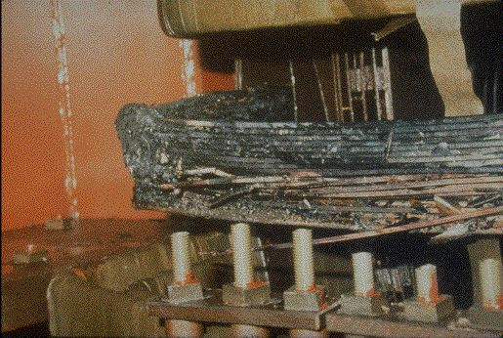
Fig. 1. The figure shows a 340 kV transformer at a nuclear plant on the Delaware River in New Jersey. The transformer was damaged by the March 1989 magnetic storm.
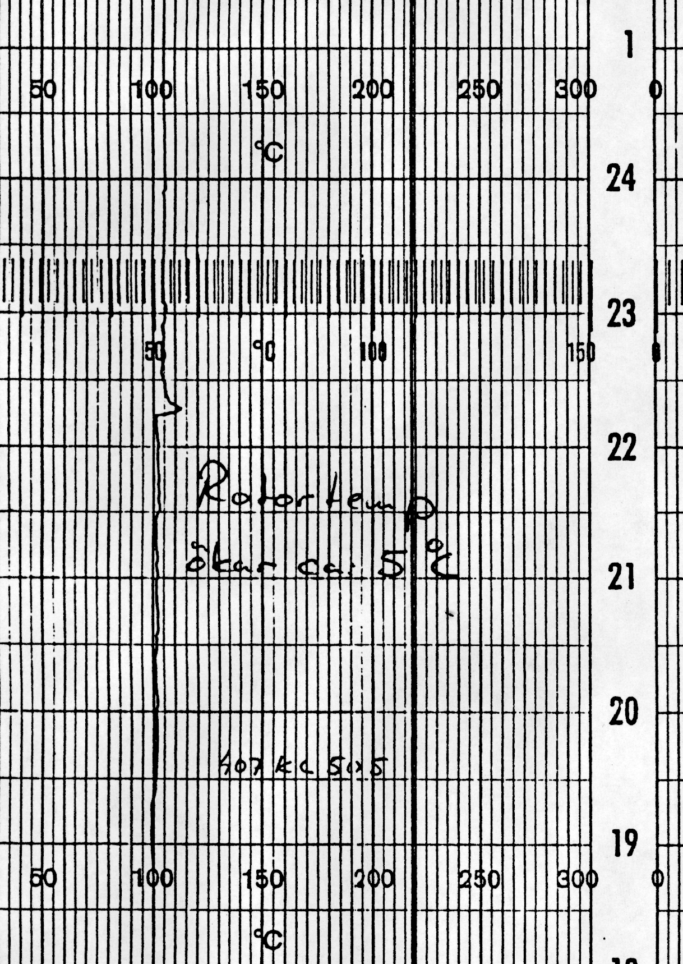
Fig. 2. The figure shows a 5 C degree increase in the temperature of a rotor in a nuclear power plant in Sweden, caused by geomagnetically induced currents as a result of the severe geomagnetic storm of March 13, 1989.
The solar wind is continuously measured by the ACE spacecraft. The solar wind passes ACE about one hour before it hits Earth. Around midnight on September 24, 1998, the solar wind magnetic field turns strongly southward (Fig. 3). At the same time, there is a sudden increase in the density and the solar wind velocity. This behaviour is typical for a fast CME.
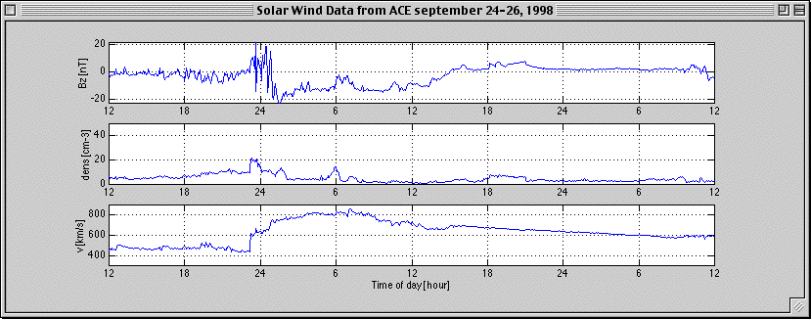
Fig. 3. The figure shows the solar wind magnetic field z-component, the particle density, and the velocity for 2 days in September 1998.
In the resulting geomagnetically induced current of the CME as measured in the earthing of a transformer neutral is shown. The transformer is connected to 400 kV grid in the south of Sweden.The bottom panel shows the geomagnetically induced potential in a gas pipeline 300 km from the transformer.
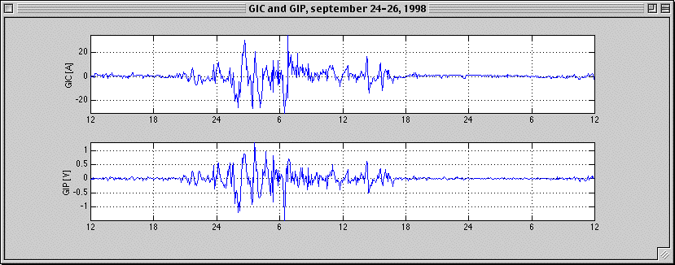
Fig. 4. The geomagnetically induced current (GIC) and the geomagnetically induced potential for the 2 days in September 1998.

Main problems
Space weather causes geomagnetically induced currents. These GICs can damage transformers and shut down power grids.
The power systems today are very large networks, consisting of thousands of substations, busses, transmission lines and transformers. Information about the system must be used as input to models which shall describe how such a system responses to a disturbance at time of a space storm.
The Swedish power industry provides a model of their power network. They can herewith simulate how a disturbance will influence the network in every point. The power industry is interested in comparing their model with the theoretical models developed by FMI [7]. A case study is therefore planned.
Forecasts of GICs require access to real-time solar wind data, information about the whole network and a computed electric field for a region as close as possible to the node of the network of interest. If forecasts of GICs are available, then they can mitigate the effects of GIC. The power industry in Sweden therefore wants real-time forecasts of GICs in all points of their network. They also want average GIC and MVAr influence per zone. From this they can finally evaluate the cost benefits of using forecasts.

Proposed solution

GIC forecast service
In September 1999 the first Nordic GIC network was formed to facilitate exchange of data and information between Nordic users and scientists interested in GICs, causes and effects.
The work within this pilot project will result in a prototype for forecasting real-time GICs in all points of the Swedish power system. The pilot project involves the whole power industry of Sweden. The prototype could in future be extended to other countries. The prototype will be a part of SWENET.
The service is planned to be available on the web. However, some restrictions will exist.
IRF Lund is one of eleven RWC within the International Space Environment Service (ISES). H. Lundstedt is Deputy Director of ISES. We therefore also have these possibilities of distributing services.

GIC forecast model
The service shall include a model to forecast GICs from solar wind data. The model is illustrated in Fig. 5. Using solar wind data at L1 (currently ACE) a first model forecasts the time derivative of the geomagnetic field at a given location in the south of Sweden (dB/dt). Then a second model uses the forecasted dB/dt, a description of the power grid layout, and ground conductivity data to compute the GICs. In the following sections we describe the dB/dt forecast model and the GIC model.
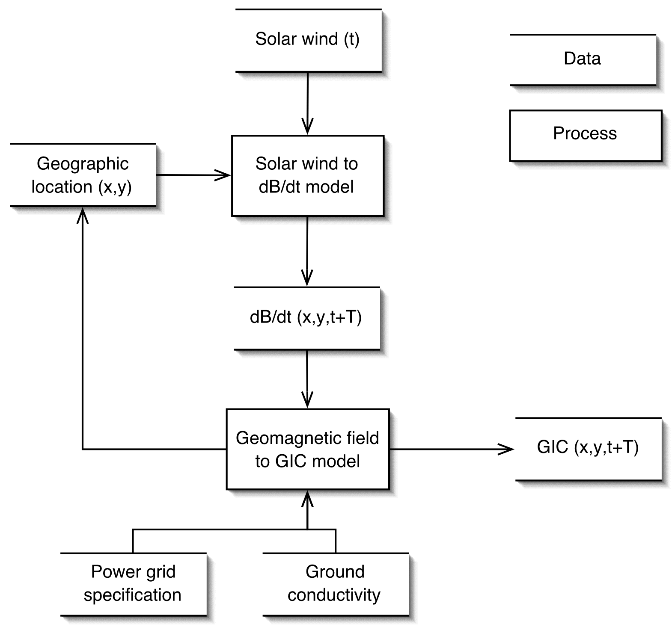
Fig. 5. The figure illustrates the model for the forecasting of GIC in a power grid from solar wind data. The geographic location is indicated with the (x,y)-coordinates. From an observed solar wind sample at time t, the forecast extends a time T into the future.
From previous studies using models that couple the solar wind to the Earth’s magnetosphere it has been shown that neural network models have been the most successful [1]. Our approach here is thus to use a neural network to forecast the time derivative of geomagnetic field (dB/dt) from real time solar wind data. To be able to train the network known input-output data pairs must exist. The input data are the solar wind data and the output data are the geomagnetic data at equidistant points. The first step will thus be to set up a database with the network input-output data to be used for training.

GIC data
From a previous study, financed by Swedish power companies, titled Forecasting and Calculating Geomagnetically Induced Currents new GIC data were collected and studied [1]. Studies were also carried out to explore forecasting of the GIC’s and will be discussed in section 5.2.7.
In the study [1] measured GIC at a transformer in Simpevarp, Oskarshamn, Sweden, were collected. The data consist of one minute resolution GIC recordings in units of Ampere (A). The dataset covers one month in 1998, and then continuously for readings over 3 A over 1999 and 2000. The dataset was partially cleaned from outliers and other artefacts.
In this project we shall use the same dataset as described above. A more thorough analysis of the data shall be made to obtain a good dataset. Key events, such as changes of the power grid configuration shall also be included in the dataset.
Additional GIC data are available after 2000 and at a few other sites in the south of Sweden during one month in 1998.
The analysis of the GIC data shall result in a dataset with good data for a number of time sequences. A classification shall be done of the GIC data to divide it into a number of classes from undisturbed to strongly disturbed events. The obtained events shall be used to identify the necessary solar wind and geomagnetic data that need to be collected.

Solar wind data
The ACE spacecraft has produced a dataset with high time resolution solar wind plasma and magnetic field data since 1997. The data we intend to use are one minute resolution data. The actual time resolution used for the model might be slightly more than one minute, e.g. five or ten minutes, an issue that will be explored in the project and is related to the accuracy of the final computation of GIC.

Computed geomagnetic data in south Sweden
The output data from the neural network model shall be the forecasted geomagnetic dB/dt data. To be able to train the network a dataset must be constructed from observed geomagnetic data.
The first step is to create a dataset of geomagnetic data. The basic dataset is provided by the IMAGE magnetometer network, and data from a few other nearby sites can be added too. The high quality standards of IMAGE guarantee that the data are usable as such without any concern of annoying errors.
Next, equivalent ionospheric currents are calculated using the method of spherical elementary current systems. This data set will be stored permanently, so it is straightforward to determine the ground magnetic field at any desired locations. A reasonable grid density is 50 km x 50 km, which is small enough compared to typical distances between power system nodes. In this way a dataset with one minute resolution geomagnetic field data can be produced. The suggested spatial resolution of 50 km leads to a dataset with about 105 B-values every minute covering and area of 1000×200 km.
In the south of Sweden the closest magnetometer sites are at Lovö (18°E,59°N), Sweden, and Brorfelde (13°E,56°N), Denmark. For this project it would be desirable to set up a new site between these two locations to obtain a better geographical coverage. It will be examined if such a site can be set up, possible close to Växjö (14°E,57°N) in Sweden. This is, however, not a mandatory part of this project and any necessary funding will be sought for outside the project.

Neural network model of dB/dt
The first step in the process of constructing a neural network model is to find suitable datasets that can be used for training, validation, and testing. The data should also be normalized to improve on the convergence towards an optimal model. Then a large number of models are trained in which various architectures are explored.
The evolution of the geomagnetic field depends on the current state of the magnetosphere and the solar wind input. This type of dynamic systems can be modeled by time delayed and recurrent networks. Such models have been developed for ionospheric and geomagnetic indices, such as Kp [1], Dst [1], AE [3], and foF2 [9] and also for local magnetic field variations [2]. The sampling rate range from 3 hours (Kp), 1 hour (Dst, foF2), 10 minutes (AE), and down to 5 minutes (local magnetic field). The prediction lead time is usually about one hour using a spacecraft at L1.
Developing a model for the prediction of dB/dt from solar wind data is certainly possible based on the previous results, but it is clear this activity includes new research. The advantage of having a model forecasting dB/dt instead of B is that we do not need to consider slow variations, such as the quiet daily variation. From the IMAGE magnetometer network we obtain a dataset of dB/dt values at any location in the south of Sweden with a spatial resolution of 50 km (see section 5.2.3).
The input to the model will be the solar wind density, velocity, and magnetic field, together with the geographical location at which dB/dt should be forecasted. The appropriate time resolution need to be determined, although it is preferred to keep it as high as possible, e.g. one minute resolution.
As the L1 point is situated about 1.5 million km upstream of the Earth the typical forecast lead time is one hour, based only on the convection of solar wind structures from L1. For higher velocities the lead time can drop to about 25 minutes.
The final desired accuracy of GICs will put constraints on how accurate the dB/dt forecasts must be. Both the timing of dB/dt structures and the amplitude must be considered when evaluating the forecasts. This will also lead to an estimate of the appropriate time resolution.

The horizontal geoelectric field
The key quantity in the calculation of geomagnetically induced currents (GICs) is the horizontal geoelectric field at the earth's surface. The electric field does not depend on the technological conductor system in question, but is fully determined by the geophysical environment: ionospheric currents and the earth's conductivity. Consequently, once the electric field is known, it can be applied to any conductor system in the study area. It is handy to use pre-calculated model field sets to simulate GICs in different configurations of the conductor system. This is especially advantageous concerning frequently changing power networks.
Because continuous geoelectric field recordings are not available in wide regions, the field must be calculated from other geophysical data. A powerful method is to use the simple relation between the local magnetic and electric fields determined by the plane wave surface impedance, which only depends on the local earth's conductivity structure. A recently compiled set of conductivity models is available in Fennoscandia, so surface impedances can be readily determined. The ground magnetic field is measured at several sites in Fennoscandia (especially the IMAGE magnetometer network) and nearby regions, which makes it possible to derive equivalent ionospheric current systems. Then the magnetic field can be interpolated at a dense grid covering the area of the power system (or any other conductor system).
Using appropriate conductivity models, the geoelectric field is then calculated in the selected grid. This is also a basic database with which GICs can be calculated in various power system configurations.
GICs are calculated using a well established DC model. An important step is to compare model values to recorded ones, and then to further modify the earth's conductivity model for a reasonable fit.

Using forecasted geomagnetic field
The procedure described above is directly applicable in forecasting assuming that the ground magnetic field or the geoelectric field is given as output of the forecast module. Because there may be a need to further update the earth's conductivity model affecting the electric field, a robust solution is to forecast the magnetic field. A feasible way is to adjust the forecast method by considering the field at the magnetic recording sites. It is also recommendable in the operative phase to forecast the field at observatory sites, because the field can then be interpolated in a denser grid as described above. The crucial challenge is to construct the forecasting module to produce the time derivative of the magnetic field as accurately as possible, because it is ultimately related to GIC rather than the magnetic variation field. A sufficient temporal resolution is one minute.
During the pilot project, a post event analysis is performed for the Oskarshamn transformer station, where measured GIC data are available. Then it is sufficient to model only the nearest parts of the high-voltage power system in the surroundings of Oskarshamn. The geoelectric field is calculated as described above, and a priori conductivity models are tuned to get a good fit between modelled and recorded GICs.

Direct forecasting of GIC
It is very likely that a model for predictions of GIC’s from the solar wind will provide the most accurate forecasts. This is due to that no simplifying assumptions need to be introduced in the chain of relations going from the observed solar wind, through the interaction with the Earth’s magnetosphere, the ionospheric current systems, down to the time varying magnetic fields at the Earth’s surface, creating geoelectric fields, and finally GIC’s. The weak point for such a model is that it can only be used to forecast GIC’s at a certain location in the power grid, for a certain power grid layout. However, a number of approaches shall be explored in order to overcome this limitation.
In the following we will assume that the observed GIC data are available in real time.
The largest GIC dataset is based on measurements at the Oskarhamn power plant. The observed GIC data at that site will depend on two factors: 1) the geoelectric field, and 2) the power grid configuration. The important inputs to a forecasting model will in this case be the solar wind data and the power grid configuration. The configuration need not be described explicitly, instead it suffices to label the different configurations. E.g., for a certain GIC recording the grid is in configuration A, for another recording the grid is in configuration B, etc.
One approach is to train different expert neural networks that each are capable of forecasting GIC’s for the different configurations. In an operational mode one uses the neural network that corresponds to the current grid configuration. It is a somewhat static approach as it might be difficult to obtain accurate forecasts for new configurations.
A second approach is to train the neural network online so that it adopts to new situations. First a neural network is trained on historic data to obtain an initial model. In operational mode, every time the power grid configuration is changed, a signal is sent to the neural network to adopt its weights for the new situation. This online training is stopped either by an error or a time criterion.
Other solutions will also be explored that may include combinations of the two above mentioned approaches. There actually might be a way to find parameters in the neural network model that correspond to changes in power grid configuration. The online training at configuration changes may then be much simplified or even unnecessary.

Model validation
The main goal of this service is to provide accurate forecasts of GIC’s at any location in the power grid in the south of Sweden. As mentioned earlier, most of the observed GIC’s are obtained at Oskarshamn. This single site provides an excellent opportunity to which the model can be evaluated. It shall be identified which part of the model that produces the largest errors. This will provide important information on the future development of the model.
Another source of comparison is the GIC model installed at OKG using software provided by the Metatech company. The model has been installed at OKG and computes the GIC’s in the power grid. In this way the GIC model proposed in this project can be evaluated against the Metatch model at several locations.

Service implementation
The software shall be installed on a server maintained by IRF. Forecast shall be accessible over the Internet.

Real-time data
In order for the service to operate in real-time solar wind data are needed. It is advantageous if also GIC data are available in real time to be used for on-line evaluation.
Currently the solar wind data from the ACE spacecraft are available with a couple of minutes time delay from SEC [8]. At times of large solar storms, generating proton fluxes above a certain threshold, the ACE plasma data are not reliable. However, it seems that the magnetic field data at those events are correct. A way to solve this problem is to use another source for the solar wind plasma data, namely the SOHO spacecraft. It must be investigated what criteria that should be used to switch from the ACE plasma data to the SOHO plasma data.
Recordings of GIC’s are made continuously at Oskarshamn whenever the GIC goes above 3 A. The data are stored locally. Software shall be developed to ensure that the GIC data are available in real time to the forecast server. Several possibilities exist here, such as ftp or email. Associated with the GIC data is the information of power grid configuration. These data may include business sensitive information. It does not pose any restrictions on this study, however, it must be agreed on what data are to be delivered.
It is suggested that the data are stored in a SQL database. MySQL provides an efficient and stable database engine from the open source community [6].

Models
The models shall be implemented in Java. However, some core algorithms might be implemented in C or Matlab. This puts some restrictions on platform dependency and that a Matlab license must exist on the server.

User interface
Within the Alcatel consortium of the ESA Space Weather Programme Study IRF-Lund developed a real-time space weather forecast prototype service. The prototype was developed in Java and runs on the internet. We plan to use the experience of developing that prototype to the developing of the GIC forecast prototype. The service will therefore web based. In a collaboration with the user the service will be tailored according to their wishes.

Work plan
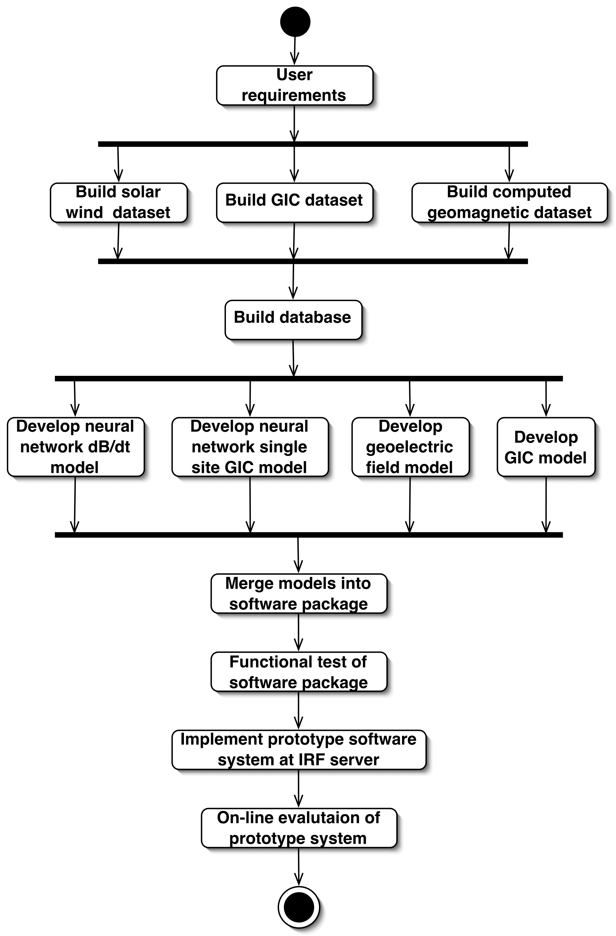

Application perspectives
Post-analysis of GIC events is adjusted in this proposal only for one transformer station. It follows that the best fit of model values can be expected around that site. However, the same procedure is applicable for the other parts of the power system, containing a fine-tuning of the earth's conductivity models and comparison of modelled GICs with measured values.
Once the geoelectric field is calculated, it can as well be applied for gas pipelines in southern Sweden. Similarly, the forecasting service could be used for that purpose.
The forecasting method could be tailored also for other countries. Especially in Canada, there is a dense magnetometer network that could provide reference data for testing.

References
- Boberg, F., P. Wintoft, and H. Lundstedt, Real time Kp predictions from solar wind data using neural networks, Phys. Chem. Earth, 25, 275–280, 2000.
- Gleisner, H., and H. Lundstedt, A neural network-based local model for prediction of geomagnetic disturbances, J. Geophys. Res., 106, 8425–8434, 2001.
- Gleisner, H., and H. Lundstedt, Auroral electrojet predictions with dynamic neural networks, J. Geophys. Res., 106, 24,541–24,550, 2001.
- Kronfeldt, I., Forecasting and Calculating Geomagnetically Induced Currents, A project within Ramverket för Elteknisk Utveckling at Sydkraft AB, Final Report, 2002.
- Lundstedt, H., H. Gleisner, and P. Wintoft, Operational forecasts of the geomagnetic Dst index, Accepted for publication in Geophys. Res. Lett., 2002.
- MySQL, http://www.mysql.com/.
- Pulkkinen, A., A. Viljanen, R. Pirjola, and Bear Working Group, Large Geomagnetically Induced Currents in the Finnish High-Voltage Power System, Finnish Meteorological Institute, Reports 2000:2, ISSN 0782-6079, 2000.
- Real time solar wind data from ACE at the SEC, http://ftp.sec.noaa.gov.
- Wintoft, P., and Lj.R. Cander, Ionospheric foF2 storm forecasting using neural networks, Phys. Chem. Earth, 25, 267–273, 2000.

