Real-time forecast service for geomagnetically induced currents

Financial, Management, and Administrative Proposal

In response to Announcement of Opportunity AO/1-4246/02/NL/LvH
Pilot Project for Space Weather Applications
Study manager: | Henrik Lundstedt
Project manager: | Peter Wintoft
Administrative manager: | Lars Eliasson

Table of contents
1 Summary 3
2 Abbreviations 3
3 Background experience of the study team 3
4 Organisation and management 4
4.1 Participating groups and key persons 4
4.2 Study organisation 4
4.3 Management approach 4
4.4 Cost and schedule control 5
5 Facilities 5
6 Key personnel 5
6.1 CV for Henrik Lundstedt 6
6.2 CV for Peter Wintoft 7
6.3 CV for Magnus Wik 8
6.4 CV for Lars Eliasson 9
6.5 CV for Risto Pirjola 10
6.6 CV for Ari Viljanen 11
6.7 CV for Antti Pulkkinen 12
6.8 CV for Håkan Swahn 13
7 Deliverable items 14
8 Work breakdown structure 15
8.1 Work breakdown 15
8.2 Work flow 16
8.3 Work packages 16
9 Planning 30
9.1 Meetings and milestones 30
9.2 Schedule 30
10 Cost price data 30
10.1 The price of the contract 30
10.2 Geographical distribution 31
10.3 Type of price 31
11 Milestones payments plan 31
12 Travel and subsistence plan 31
13 Contract conditions 31

Summary
This document contains a description of the organisation and management of the project Real-Time Forecast Service of Geomagnetically Induced Current. The background experience and facilities of the companies are given. The key personnel taking part in the project are identified. The items to be delivered are listed. The project is divided into a number of work packages with their relations described in the work breakdown structure and the work flow. A plan is given for important meetings and scheduled deliverables. The cost of the project and the payments plan are stated. A travel plan is described, and finally, the contract conditions are given.

Abbreviations
In this document the following abbreviations are used:
ESA | European Space Agency
FMI | Finnish Meteorological Institute
GIC | Geomagnetically induced current
IRF | Swedish Institute of Space Physics
IRF-K | Swedish Institute of Space Physics, Kiruna
IRF-L | Swedish Institute of Space Physics, Lund
ISES | International Space Environment Service
MTR | Mid-term review
OKG | Oskarhamns Kraftverkgrupp

Background experience of the study team
Both the contractor (IRF) and the sub-contractor (FMI) have a long experience of research and model development in space weather and its relation to geomagnetically induced currents (GIC). IRF and FMI have previously managed and successfully completed several ESA projects of similar size. IRF/FMI shall be the provider of the suggested forecast service.
The user of the forecast service shall be Oskarhamns Kraftverkgrupp AB (OKG) situated at the east coast of Sweden. OKG is responsible for the operation of a nuclear power plant housing three reactors. OKG is greatly interested in understanding the relation between space weather and GIC’s and has for many years performed studies of GIC’s. OKG is involved in a GIC programme funded by Elforsk AB.
Elforsk AB (Ltd), which was established in 1992, is own by Svensk Energi (Swedenergy) and Svenska Kraftnät (the Swedish National Grid). The business is organized in five programme areas: Hydro Power, Electricity and Heat Production, Transmission and Distribution, Utilisation, and Strategies and Systems. The deregulated electricity market within EU, the major electricity supply companies' increasing international involvement and various EC directives all mean that solutions to a number of issues should be sought in a European rather than a Swedish or a Nordic context. It is Elforsk's intention during 2002 to draw up a business plan for R&D collaboration within EU.
FMI/GEO has performed GIC research for 25 years in a close co-operation with industry. Modelling work has dealt with the calculation of the geoelectric field due to complicated auroral current systems. GIC computation models have been derived for power systems and pipelines. Modelled GICs have been compared with measured values both in the Finnish high-voltage power system and in the Finnish natural gas pipeline. Statistical predictions of the GIC occurrence in these systems have been derived based on long geomagnetic time series. FMI/GEO has also had own GIC recordings by using a magnetometer close to a power line (1991-92) and above the natural gas pipeline (since 1998). FMI/GEO has performed altogether 8 GIC projects supported by Finnish companies, and one study for the Electric Research and Management, Inc. (United States). Furthermore, FMI/GEO was responsible for GIC issues in the ESA/ESWS study.
IRF is one of the leading research institutes in experimental and theoretical space and atmospheric physics, including magnetospheric and ionospheric physics, and solar physics and space weather. Measurements are made by satellites, sounding rockets, meteorological balloons, ground based magnetometers, ionosondes, and radar. IRF has also adopted the very powerful concept of knowledge based neuro computing to develop models of various processes in the Sun-Earth interaction. The models are generally suitable for real time forecasts. IRF/lund has collaborated with the Swedish power industry for more than 20 years. Several GIC projects have been funded by ELFORSK, Sydkraft, ABB and NUTEK.

Organisation and management

Participating groups and key persons
The study team is composed of highly competent scientists from the Swedish Institute of Space Physics (IRF) and the Finnish Meteorological Institute (FMI).
Dr. Henrik Lundstedt, Head of the IRF-Lund group and Deputy Director of ISES, is appointed as the Study Manager and will have the authority to direct necessary resources to carry out the studies in accordance with the contract.

Study organisation
The study is organised according to the major work packages as described in Section Work breakdown structure.
Dr. Lars Eliasson will be the Contracts Officer. As such he will be the point of contact in all contractual matters with ESA.
Dr. Peter Wintoft will be the Project Manager. As such he will be the point of contact for all technical matters with ESA.

Management approach
The project management follows the management principles of small size research organisation with experience of international hardware, software, and study projects in the field of space research. Considering the relatively small size of the project, it is necessary to keep the management and control functions efficient but at the same time within reasonable limits.
The overall management is the responsibility of the Contractor and the Study Manager.
The management and project control is defined in a separate work package (WP 700) and is lead by the Administrative Manager.
The Administrative Manager has full control of, and responsibility for, the means by which the budget is spent. He has the full authority to represent IRF and make all necessary decisions for this project. The Administrative Manager also plays the role of Contracts Officer.

Cost and schedule control
The costs and schedules are controlled by the ordinary control tools. Since the only costs to the ESA contract are labour and travel, the cost control procedures are very simple. The schedules are controlled through the monthly reports and are part of WP 700.

Facilities
The contractor, and sub-contractor, has fully sufficient facilities to be used in the project. All the required computing resources are free of charge to the project. Any purchase of equipment to the project will be taken care of by the contractors own resources and will remain the property of the respective institutes.

Key personnel
The key persons taking part in the project are indicated in the table below and in the rest of the section their respective CV’s follow. In addition to this, other persons that will take part in the project are: Ingmar Kronfeldt (WM-Data AB), Hans Gleisner (ESA Fellow at DMI), and Leif Kalla (IRF-Kiruna).
Key person | Affiliation | Responsibilities
Henrik Lundstedt | IRF-Lund | Study manager.  Manager WP 100, 500.
Peter Wintoft | IRF-Lund | Project manager.  Manager WP 200, 201, 400, 401, 501.
Lars Eliasson | IRF-Kiruna | Administrative manager.  Manager WP 700.
Magnus Wik | IRF-Lund | Manager WP 402.
Risto Pirjola | FMI | Manager WP 302.
Ari Viljanen | FMI | Manager WP 300, 301.
Antti Pulkkinen | FMI | Manager WP 202.
Håkan Swahn | OKG | Service user contact person.

CV for Henrik Lundstedt
Name: | Henrik Lundstedt
Address: | Swedish Institute of Space Physics, Solar-Terrestrial Physics Division, Scheelevägen 17, SE-223 70 Lund
Phone: | +46 46 286 21 20
Email: | henrik@lund.irf.se
Year of birth: | 1949
Degrees: | PhD in Astronomy, Lund University, 1983  Docent, Lund University, 1993
Position: | Permanent position as Scientist at the Swedish Institute of Space Physics and Head of the Lund division, 1997–
Main research interest
To understand the solar magnetic activity, i.e. the driver of the space weather. To describe it with intelligent hybrid systems and to develop forecasts of it and its effects on earth’s atmosphere and technological systems.
Professional experience
- Visiting scholar 1979–1981 at Stanford University, California, USA.
- Collaborating with the Stanford group on MDI/SOHO solar magnetic field studies.
- PI of an international consortium for the development of a sub-arcsecond CCD video magnetograph for the Swedish Vacuum Solar Telescope at La Palma.
- More than 20 years experience of studies and observations of the solar magnetic field. Studies of the solar wind plasma and magnetic fields and the solar wind interaction with earth’s magnetosphere and comets.
- Suggested a solar-climate/weather coupling in early eighties.
- Introduced the use of artificial intelligence methods, such as expert systems and neural networks, into solar-terrestrial physics studies.
- Arranged two international workshops in Lund on the subject (AI Applications in Solar-Terrestrial Physics, 1993 and 1997).
- Developed the first model of the solar wind magnetosphere interaction based on neural networks.
- Sub-contractor of the ESA Space Weather Programme led by Alcatel Space. Work package leader on a space weather forecast prototype and space weather service.
- Outlined a European Space Weather Center.
- Deputy Director of the International Space Environment Service (ISES).
- Responsible of Lund Space Weather Center and Regional Warning Center Sweden.
- Member of the ESA Space Weather Working Team.
- Archives the Space Weather Euro News (SWEN).
- Invited talks given at AGU, IAGA, COSPAR and Chapman conferences, USA; the S-RAMP conference, Japan; IAGA/IUGG meetings, UK; EGS meetings, France and The Netherlands; ESA/ESTEC conferences; Convener at several conferences.
Publications
- Author or co-author to more than 90 articles.

CV for Peter Wintoft
Name: | Peter Wintoft
Address: | Swedish Institute of Space Physics, Solar-Terrestrial Physics Division, Scheelevägen 17, SE-223 70 Lund
Phone: | +46 46 286 21 21
Email: | peter@lund.irf.se
Year of birth: | 1965
Degrees: | MSc in applied physics, 1991, Linköping University  PhD in Astronomy, 1998, at Lund University
Position: | Permanent position as Scientist at the Swedish Institute of Space Physics, 1997 –

Main research interest
Space weather research and developing knowledge based neuro computing models.

Professional experience
- Visiting scientist at the Radio Communications Research Group, Rutherford Appleton Laboratory, UK, April 1998 – June 1998.
- Work package co-leader in the COST 271 project (European Co-operation in the field of Scientific and Technical Research), 2000 – 2001.
- Technical Manager and lead scientist in the ESA project Development of AI Methods in Spacecraft Anomaly Predictions, 1999-2001.
- Several years of experience in solar-terrestrial physics and neural networks.
- Given talks and presented posters at several conferences: EGS, The Netherlands; COSPAR, UK; ESA/ESTEC, The Netherlands; Space Weather Week, USA; S-RAMP, Japan.
- Involved in the arrangement of the two workshops in Lund on AI Applications in Solar-Terrestrial Physics, 1993 and 1997. Planning of a third workshop in May 2003.

Publications and software
- Author or co-author to more than 30 articles.
- Author to five technical notes, three user requirement documents, and software requirement document for the ESA contract on satellite anomalies (1998-2001).
- Project leader for the development of a software package, containing more than 40 000 lines of Java code, as part of the ESA contract on satellite anomalies (1998-2001).

CV for Magnus Wik
Name: | Magnus Wik
Address: | Swedish Institute of Space Physics, Solar-Terrestrial Physics Division, Scheelevägen 17, SE-223 70 Lund
Phone: | +46 46 286 21 25
Email: | magnus@lund.irf.se
Year of birth: | 1969
Degrees: | MSc in Space Physics, 2000, Lund University
Position: | PhD student at the Swedish Institute of Space Physics, 2002 –

Main research interest
Research in Space Weather and its influence on climate and electrical systems on Earth. Continue developing neuro computing models for forecasting geomagnetically induced currents.

Professional experience
- Visiting research assistant at University of Waterloo, Canada, Nov. 2001-Aug.2002
- Research project at Geomagnetic Laboratory in Ottawa, Canada, 2001

CV for Lars Eliasson
Name: | Lars Eliasson
Address: | Swedish Institute of Space Physics, P.O. Box 812, SE-981 28 Kiruna, Sweden
Phone: | +46-980 790 87
Email: | lars.eliasson@irf.se
Year of birth: | 1950
Degrees: | Ph.D. in space physics, Umeå University, 1994  Docent, Umeå University 2000
Position: | Deputy Director, Swedish Institute of Space Physics

Main research interest
Studies of spacecraft environment interaction. Experimental investigations of
electron and ion heating/acceleration processes. Development of hot plasma
instruments for studies in planetary magnetospheres and ionospheres with
special emphasis on auroral phenomena.

Professional experience
- Director of the National Graduate School of Space Technology, Luleå University of Technology 2001-present.
- Head of Kiruna Division, Swedish Institute of Space Physics 1997-2000.
- Acting Head of Uppsala Division, Swedish Institute of Space Physics 1996.
- Research fellow (forskarassistent) Umeå University 1995-99.
- Sci. Staff Member, Swedish Institute of Space Physics 1974-present.
- Teaching assistant, Dept of Physics, Umeå University 1974-78.
- Principal Investigator: Hot plasma experiment F3H (Freja) and Hot plasma experiments on three sounding rockets (Project Scientist for the Aureld-H sounding rocket)
- Co-I: Hot plasma experiment V3 (Viking), Cold plasma experiment F3C (Freja), Correlator experiment F7 (Freja, Ion composition experiment ESIC (Equator-S), Ion composition experiment CIS (CLUSTER)
- Have been member of program and organizing committees, e.g., SAR88, ESA/PAC Symposium 1989, RVK96, IPELS97, 7th SCTC 2001
- Have given invited talks at conferences in, e.g., Sweden, USA, Germany, Scotland, Hong Kong, Canada, Portugal.
- Have been referee for JGR, JGG, GRL, APUAR, JASTP, Annales Geophysicae, Phys Chem. Earth, and research proposals, for NASA, NSF, RDRC, Research Council of Norway.
- Have been study manager for three ESTEC contracts related to spacecraft plasma interactions (Sub-contract WP200 11974/96/NL/JG(SC) "Study of plasma and energetic electron environment and effects", Contract No. 13561/99/NL/SB "Plasma and Energetic Electron Environment and Effects Extension S/C Anomaly Analysis", and Contract No. 13590/99/NL/MV "Investigation of plasma-induced charging of satellite systems".)

Publications
Author or co-author of more than 90 publications.

CV for Risto Pirjola
Name: | Risto Pirjola
Address: | Vuorikatu 15 A, P. O. Box 503, 00101 Helsinki, Finland
Phone: | +358-9-19294652
Email: | risto.pirjola@fmi.fi
Year of birth: | 1950
Degrees: | M.Sc. in mathematics, University of Helsinki, 1971  Ph.D. intheoretical physics, University of Helsinki, 1982
Position: | Scientist,Finnish Meteorological Institute, Geophysical Research Division

Main research interest
Space weather, geomagnetically induced currents, electromagnetic theory.

Professional experience
- Official Member of Commission E (“Electromagnetic Noise and Interference”) of the Inter-national Union of Radio Science (URSI) in 1976 to 2000, and Chairman of URSI-E Working Group E8 on geomagnetic EMC effects in 1996 to 2000
- Representative of the Finnish Meteorological Institute at the Finnish National Committee of the Inter-national Union of Radio Science (URSI) since January 1997
- Member of the International Mars Exploration Working Group (IMEWG), 1994–1997
- Member of the North American SUNBURST group investigating geomagnetically induced currents in electric power transmission systems since 1994
- Visiting scientist at the Geomagnetic Laboratory of the Geological Survey of Canada in Ottawa, Ontario, Canada, from February to August 1996
- Lectures on Applications of Electrodynamics (in Finnish) at the Department of Theoretical Physics of the University of Helsinki, Finland, in 1987 and 1991
- Lectures and consulting work on the geoelectric field and geomagnetically induced currents at the Manitoba Hydro power company in Winnipeg, Manitoba, Canada, on May 13 to 17, 1996
- Member of the Board of the Graduate School of Applied Electromagnetics funded by the Ministry of Education, Finland, since 1998
- Guest Editor for a Special Issue of Journal of Atmospheric and Solar-Terrestrial Physics on Space Weather in 1999 to 2002
- Chairman of the Organizing Committee of the XXV Finnish National Convention on Radio Science (URSI), Helsinki, Finland, September 2000

Publications
- About 55 papers in international refereed journals
- About 80 other publications
- A great number of invited and other presentations at international scientific conferences

CV for Ari Viljanen
Name: | Ari Viljanen
Address: | Vuorikatu 15 A, P. O. Box 503, 00101 Helsinki, Finland
Phone: | +358-9-19294668
Email: | ari.viljanen@fmi.fi
Year of birth: | 1963
Degrees: | Ph.D. in theoretical physics, University of Helsinki, Finland, 1992
Position: | Senior Scientist at the Geophysical Research Division, Finnish Meteorological Institute

Main research interest
Space weather, geomagnetic variations, geomagnetically induced currents.

Professional experience
Dr. Viljanen has worked at the Finnish Meteorological Institute since 1989. He has a wide experience in theoretical modelling of geomagnetic variations and geomagnetic induction at auroral latitudes. He has also participated in the development of modelling techniques on geomagnetically induced currents in power systems and pipelines, and participated in several related investigations in co-operation with industrial companies. He was also involved in the Study of Plasma and Energetic Electron Environment and Effects (SPEE) as developing a space weather server.

In addition to the research work, Dr. Viljanen has worked as a teaching assistant (1985-86) and as a lecture (1994, 2002) in physics at the University of Helsinki.

Dr. Viljanen has been the Principal Investigator of the IMAGE magnetometer network since 1995. He has been the Finnish official member of the URSI Scientific Commission E (Electromagnetic Noise and Interference) since 2000. He has been nominated a Finnish management committee member within the COST 724 Action ("Developing the Scientific Basis for Monitoring, Modelling and Predicting Space Weather") to start in 2003.

Publications
Dr. Viljanen is an author or coauthor in 42 scientific articles appeared in refereed journals or books.

CV for Antti Pulkkinen
Name: | Antti Pulkkinen
Address: | Vuorikatu 15 A, P. O. Box 503, 00101 Helsinki, Finland
Phone: | +358-9-19294694
Email: | Antti.Pulkkinen@fmi.fi
Year of birth: | 1974
Degrees: | High school examination, Linnan Lukio, Kajaani, 1993  Master of science, University of Helsinki, 1999
Position: | Scientist, Finnish Meteorological Institute, Geophysical Research

Main research interest
Space weather effects on ground, modelling of ionospheric currents.

Professional experience
- Trainee, Finnish Meteorological Institute, June 1, 1998 – August 31, 1999
- Scientist, Finnish Meteorological Institute, September 1, 1999 – present

Publications
Author and co-author to more than 10 articles.

CV for Håkan Swahn
Name: Håkan Swahn
Address: OKG AB, Elteknik O3, 572 83 Oskarshamn
Phone: +46 491 787616
E.mail: hakan.swahn@okg.sydkraft.se
Date of birth: September 26, 1963

Present position: Electrical Engineer/specialist power apparatus at OKG AB

Education: B.Sc.EE at Linköping Technical Institute

Authorization: Holder of Swedish Government Certificate for electrical installations on all voltage levels.

Professional Experience:
- Maintenance engineer, specialist on switchgear, switchgear apparatus maintenance, commissioning training, disturbance analysis and investigations, reliability analysis, maintenance instruction development, maintenance instructor,
maintenance method development. Project manager.

1985-1989 Erection and maintenance of MV an LV networks, OH-lines,
underground cables. Substation MAP drawing and installation
of MBS receivers.

  - Erection and maintenance of MV an LV networks, OH-lines,
Underground cables and substations. Installation and maintenance
Of tha automatic equipment at the municipal waterworks.

1983-1984 Installation and repairing of sophisticated supervising systems.

Special Commissions:
Project manager for purchasing and installing a new GSU transformer, 550 MVA.

Responsible of the electrical parts in a project that is going to upgrade the electrical part of the second nuclear unit at OKG. Mainly including generator, transformer and auxillary systems in the plant.

Instructor for several different techniques and methods regarding HV engineering, Development of expert system for fault a analysis on circuit breakers.

Project Manager for maintenance and erection projects.

Deliverable items
The project shall result in a number of documents and a software package.
The following documents shall be delivered:
- User requirements document (URD),
- Software requirements document (SRD),
- Software test protocol,
- Three technical notes,
- Cost-benefit report.
The software package delivered shall contain:
- Source code and compiled code in Java (also containing pcoded MatLab software),
- Database,
- System manual,
- User manual.
In addition to this monthly reports shall be delivered. A web server will be set up from which the deliverables can be downloaded.

Work breakdown structure

Work breakdown
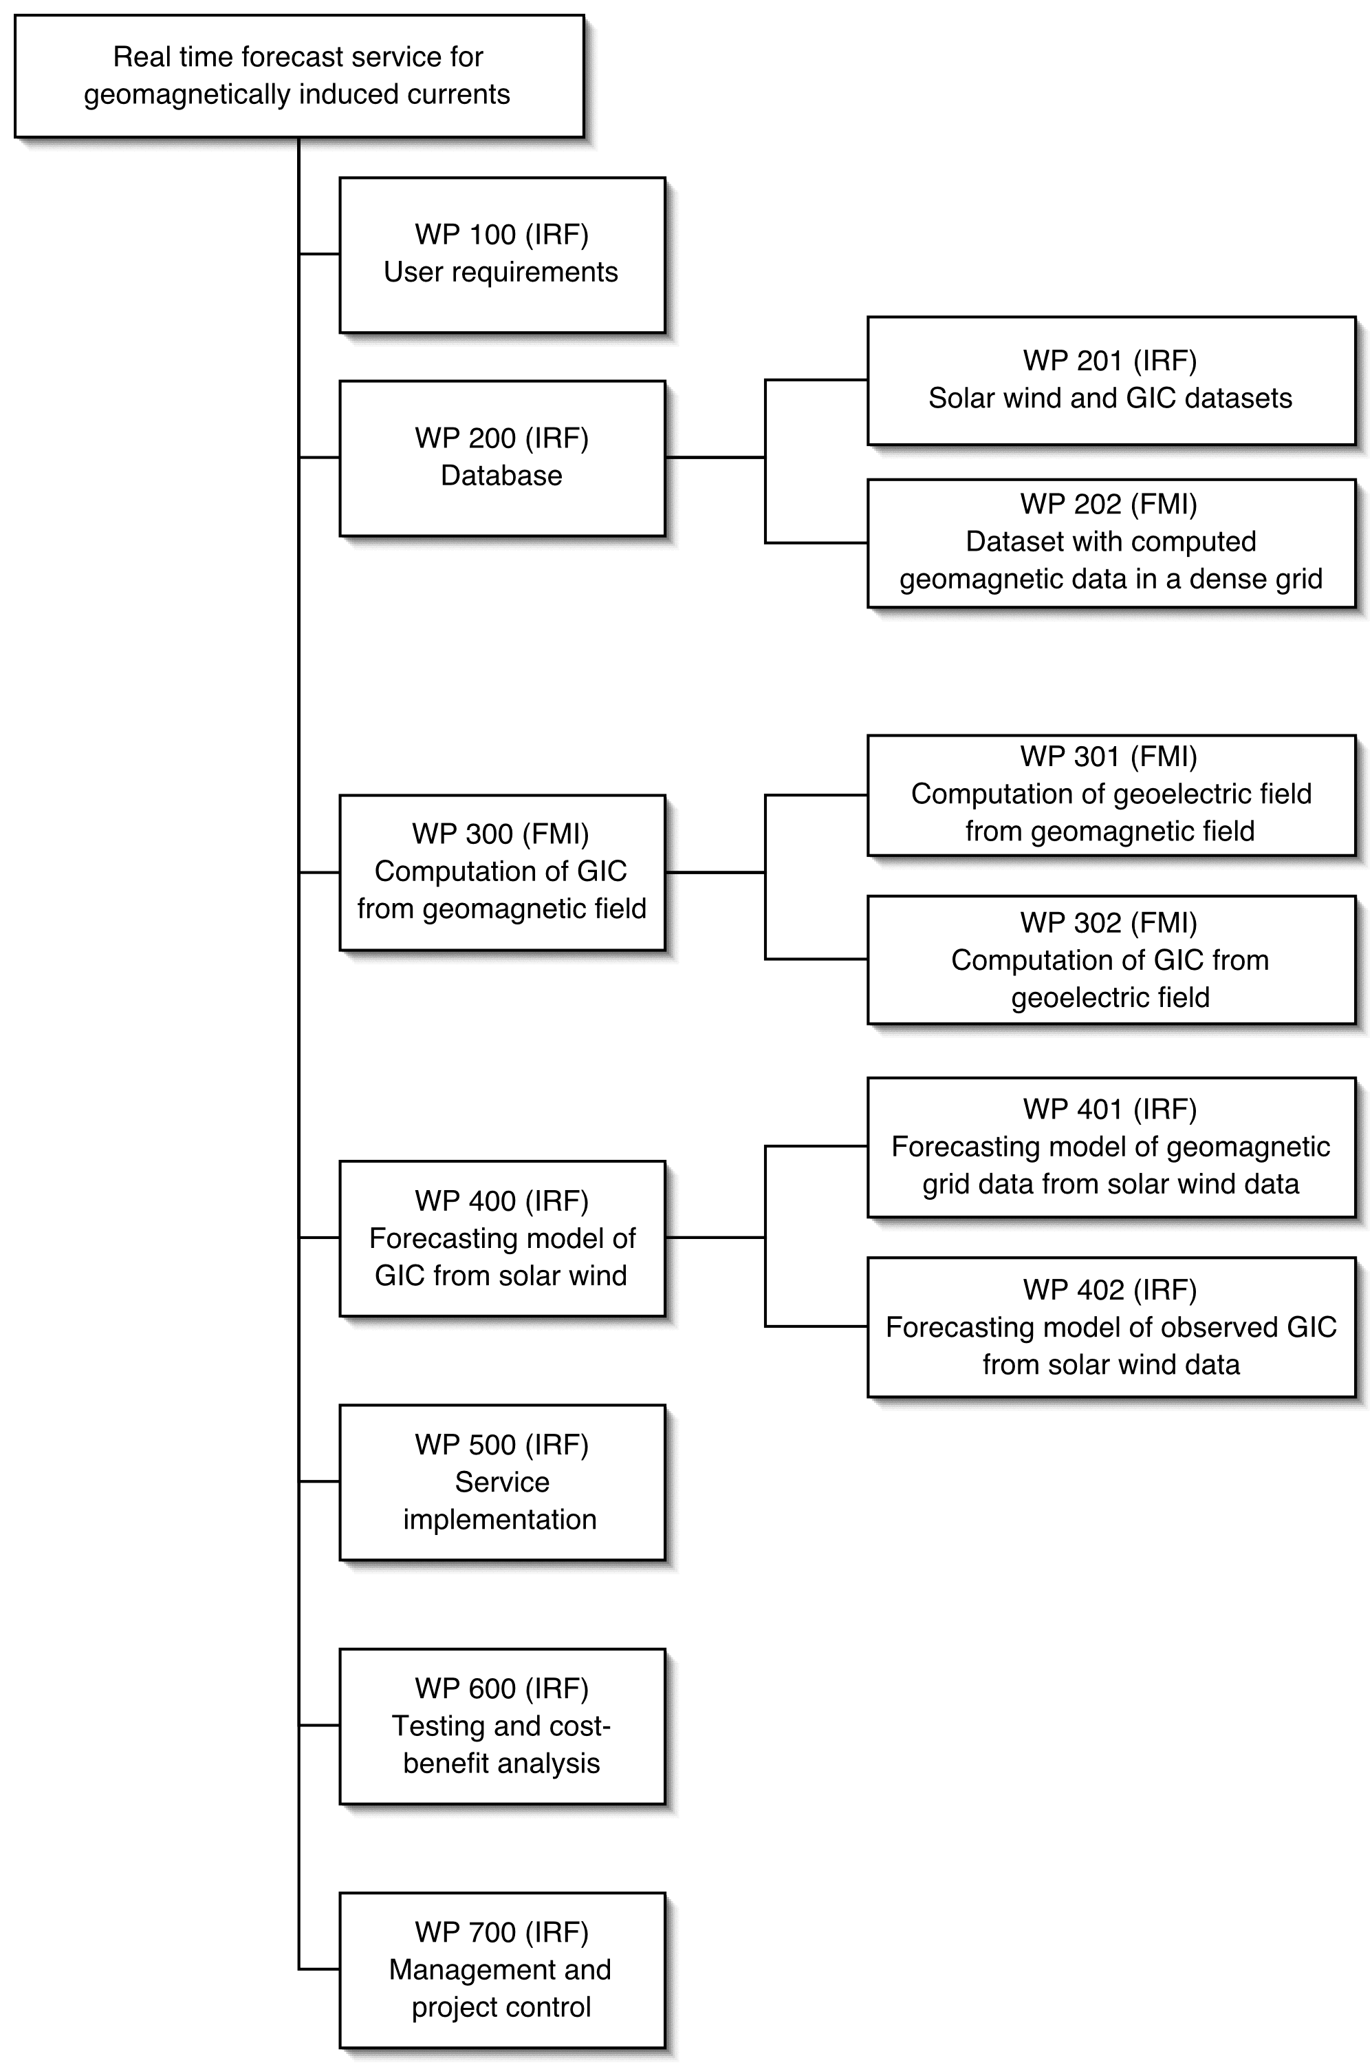
Fig. 1. The work breakdown structure. The work package managers affiliation is indicated in parenthesis. Each work package is described in the section 8.3.

Work flow
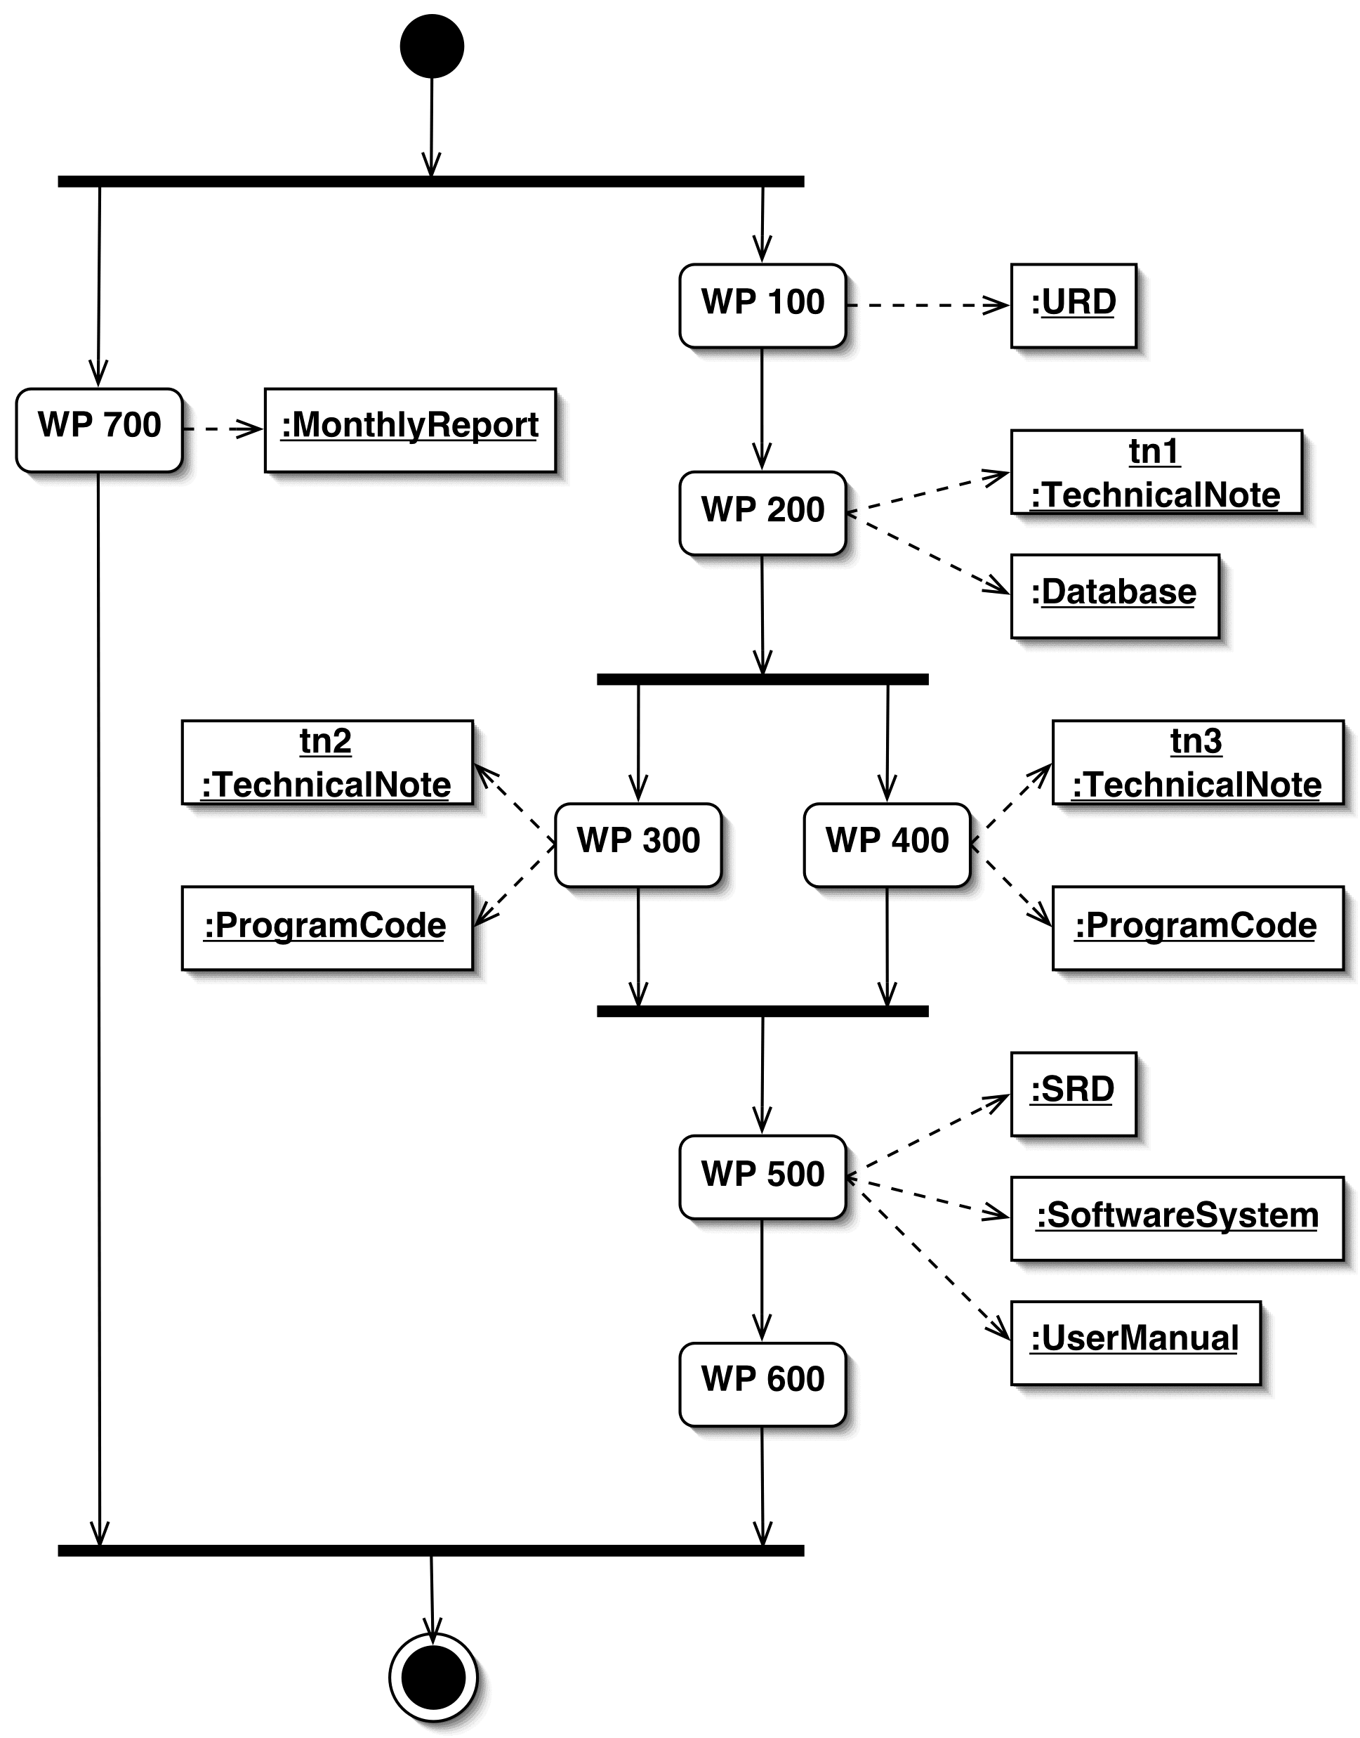
Fig. 2. The work flow with activities and outputs.

Work packages
Each work package can be identified by its unique title and number. The titles and numbers are the same as given in the work breakdown structure (Fig. 1). The date indicates when the WP description was last modified. Each WP is associated with a start and end event which marks the start and end of the WP. The estimated start and end time is given in months relative to the project kick-off at T0.

Project: | Real time forecast service for geomagnetically induced currents |  |  |  |  | WP 100
WP Title: | User requirements. |  |  |  |  | 2002-10-29
Contractor: |  |  |  | IRF
Major constituents: |  |  |  | Identification of user requirements and documentation.
WP Manager: |  |  |  | Henrik Lundstedt
Start event: |  | Kick-off |  |  | Planned date: | T0
End event: |  | Approved URD by ESA. |  |  | Planned date: | T0+3
WP Description: |  |  | - Meeting at OKG with participants from IRF at T0+0.5. FMI participate via telephone.  - Draft URD at T0+1.  - Updated URD at T0+2.  - Final URD at T0+3.
WP Output: |  |  | URD.

Project: | Real time forecast service for geomagnetically induced currents |  |  |  |  | WP 200
WP Title: | Database |  |  |  |  | 2002-11-01
Contractor: |  |  |  | IRF
Major constituents: |  |  |  | Data mining and analysis.
WP Manager: |  |  |  | Peter Wintoft
Start event: |  | Completed URD. |  |  | Planned date: | T0+3
End event: |  | Functional database. |  |  | Planned date: | T0+5
WP Description: |  |  | - Define data to be used from the URD.  - Synchronize WP 201 and WP 202 activities.  - Construct datasets with GIC data and solar wind data (WP 201).  - Construct dataset with gridded values of the geomagnetic field (WP 202).  - Merge datasets into a database.
WP Output: |  |  | - A database with gridded geomagnetic data, solar wind data, and GIC data.  - Technical note.

Project: | Real time forecast service for geomagnetically induced currents |  |  |  |  | WP 201
WP Title: | Solar wind and GIC datasets. |  |  |  |  | 2002-10-30
Contractor: |  |  |  | IRF
Major constituents: |  |  |  | Data mining and analysis.
WP Manager: |  |  |  | Peter Wintoft
Start event: |  | Input from WP 200. |  |  | Planned date: | T0+3
End event: |  | Completed dataset. |  |  | Planned date: | T0+4.5
WP Input: |  |  | - WP 200.
WP Description: |  |  | - Collect solar wind data.  - Collect observed GIC data from south Sweden.  - Describe power grid layout for the GIC periods.  - Statistical analysis of solar wind and GIC data.
WP Output: |  |  | - Dataset with GIC data.  - Input to WP 200 technical note.

Project: | Real time forecast service for geomagnetically induced currents |  |  |  |  | WP 202
WP Title: | Dataset with computed geomagnetic data in a dense grid |  |  |  |  | 2002-10-30
Contractor: |  |  |  | FMI
Major constituents: |  |  |  | Data mining and computing.
WP Manager: |  |  |  | Antti Pulkkinen
Start event: |  | Completed WP 100. |  |  | Planned date: | T0+3
End event: |  | Completed dataset. |  |  | Planned date: | T0+5
WP Input: |  |  | - WP 200.
WP Description: |  |  | - Selection of representative events.  - Collection of the geomagnetic database.  - Calculation of the ionospheric equivalent currents.  - Calculation of the ground magnetic field in a dense grid.
WP Output: |  |  | - Software package (MatLab).  - Dataset ionospheric equivalent currents.  - Dataset of the ground magnetic field in a dense grid.

Project: | Real time forecast service for geomagnetically induced currents |  |  |  |  | WP 300
WP Title: | Computation of GIC from geomagnetic field |  |  |  |  | 2002-10-30
Contractor: |  |  |  | FMI
Major constituents: |  |  |  | Model application
WP Manager: |  |  |  | Ari Viljanen
Start event: |  | Completed WP 201. |  |  | Planned date: | T0+5
End event: |  | Completed software package |  |  | Planned date: | T0+13
WP Description: |  |  | - Calculation of geoelectric field from geomagnetic data (WP 301).  - Calculation of GIC’s due to the geoelectric field (WP 302).  - Merge programs to obtain GIC from geomagnetic data.
WP Output: |  |  | - Software package (MatLab).  - Technical note.

Project: | Real time forecast service for geomagnetically induced currents |  |  |  |  | WP 301
WP Title: | Computation of geoelectric field from geomagnetic field |  |  |  |  | 2002-10-30
Contractor: |  |  |  | FMI
Major constituents: |  |  |  | Model application
WP Manager: |  |  |  | Ari Viljanen
Start event: |  | Completed WP201. |  |  | Planned date: | T0+5
End event: |  | Completed software package |  |  | Planned date: | T0+8
WP Description: |  |  | - Calculation of geoelectric field from geomagnetic field.  - Compilation of preliminary Earth’s conductivity models.  - Adjustment of the fast computation of the electric field.
WP Output: |  |  | - Dataset of the calculated geoelectric field.  - Software package (MatLab).

Project: | Real time forecast service for geomagnetically induced currents |  |  |  |  | WP 302
WP Title: | Computation of GIC from the geoelectric field |  |  |  |  | 2002-10-30
Contractor: |  |  |  | FMI
Major constituents: |  |  |  | Model application
WP Manager: |  |  |  | Risto Pirjola
Start event: |  | Completed WP 301. |  |  | Planned date: | T0+8
End event: |  | Completed software package |  |  | Planned date: | T0+13
WP Description: |  |  | - Calculation of GIC at Oskarshamn.  - Comparison with measured values at Oskarshamn.  - Adjustment of the earth model close to Oskarshamn.
WP Input: |  |  | - DC model of the power system close to Oskarshamn (WP 201).
WP Output: |  |  | - Software package (MatLab).  - Dataset of the calculated GIC at Oskarshamn.

Project: | Real time forecast service for geomagnetically induced currents |  |  |  |  | WP 400
WP Title: | Forecasting model of GIC from solar wind data |  |  |  |  | 2002-10-30
Contractor: |  |  |  | IRF
Major constituents: |  |  |  | Model development
WP Manager: |  |  |  | Peter Wintoft
Start event: |  | Completed database from WP 200 |  |  | Planned date: | T0+5
End event: |  | Completed software package |  |  | Planned date: | T0+9
WP Description: |  |  | - Synchronization of WP 401 and WP 402.  - WP 401 forecast model.  - WP 402 forecast model.  - Merge forecast models.
WP Output: |  |  | - Software package.  - Technical note.

Project: | Real time forecast service for geomagnetically induced currents |  |  |  |  | WP 401
WP Title: | Forecasting model of geomag. grid data from solar wind |  |  |  |  | 2002-10-30
Contractor: |  |  |  | IRF
Major constituents: |  |  |  | Model development
WP Manager: |  |  |  | Peter Wintoft
Start event: |  | Input from WP 400 |  |  | Planned date: | T0+5
End event: |  | Completed software package |  |  | Planned date: | T0+8.5
WP Description: |  |  | - Create datasets for training, validation, and testing.  - Identify neural network architectures.  - Train and validate neural networks.  - Identify optimal neural network for implementation.  - Develop software package implementing the optimal model.  - Test model.
WP Output: |  |  | - Software package.  - Input to WP 400 technical note.

Project: | Real time forecast service for geomagnetically induced currents |  |  |  |  | WP 402
WP Title: | Forecasting model of observed GIC from solar wind |  |  |  |  | 2002-10-30
Contractor: |  |  |  | IRF
Major constituents: |  |  |  | Model development
WP Manager: |  |  |  | Magnus Wik
Start event: |  | Input from WP 400 |  |  | Planned date: | T0+5
End event: |  | Completed software package |  |  | Planned date: | T0+8.5
WP Description: |  |  | - Create datasets for training, validation, and testing.  - Identify neural network architectures.  - Train and validate neural networks.  - Identify optimal neural network for implementation.  - Develop software package implementing the optimal model.  - Test model.
WP Output: |  |  | - Software package.  - Input to WP 400 technical note.

Project: | Real time forecast service for geomagnetically induced currents |  |  |  |  | WP 500
WP Title: | Service implementation |  |  |  |  | 2002-10-30
Contractor: |  |  |  | IRF
Major constituents: |  |  |  | Analysis and programming
WP Manager: |  |  |  | Henrik Lundstedt
Start event: |  | Completed URD. |  |  | Planned date: | T0+4
End event: |  | Completed and functionally tested software prototype system |  |  | Planned date: | T0+14
WP Description: |  |  | - Specify software requirements.  - Develop real time service for data acquisition.  - Develop real time models from WP 300 and WP 400.  - Develop user interface.  - Develop web service.  - Implement real time forecast prototype service.  - Perform functional testing.
WP Output: |  |  | - SRD.  - Prototype software system.  - Manuals.  - User manual.  - Test report.

Project: | Real time forecast service for geomagnetically induced currents |  |  |  |  | WP 600
WP Title: | Cost-benefit analysis |  |  |  |  | 2002-10-30
Contractor: |  |  |  | IRF
Major constituents: |  |  |  | Testing and analysis
WP Manager: |  |  |  | Henrik Lundstedt
Start event: |  | Completed prototype service |  |  | Planned date: | T0+12
End event: |  | Final presentation |  |  | Planned date: | T0+24
WP Description: |  |  | - Develop test plan.  - Run prototype forecast service.  - Monitor service status and forecast reliability.  - Identify important GIC events.  - Obtain information about OKG actions based on forecasts.  - Perform a cost-benefit analysis.
WP Output: |  |  | - Cost-benefit report

Project: | Real time forecast service for geomagnetically induced currents |  |  |  |  | WP 700
WP Title: | Management |  |  |  |  | 2002-10-30
Contractor: |  |  |  | IRF
Major constituents: |  |  |  | Management
WP Manager: |  |  |  | Lars Eliasson
Start event: |  | Kick-off |  |  | Planned date: | T0
End event: |  | Final delivery to ESA |  |  | Planned date: | T0+24
WP Description: |  |  | - Production of monthly reports  - Production of PM reports  - Payments
WP Output: |  |  | - Monthly reports  - PM reports  - Business plan

Planning

Meetings and milestones
The kick-off meeting shall be held as a teleconference and involve all organisations (IRF, FMI, OKG, ESA).
The Final Presentation shall be held at ESTEC.
In addition to this 5 Progress Meetings shall take place:
- PM 1 at IRF-Lund 3 months after KO.
- PM 2 at FMI 8 months after KO.
- PM 3 at OKG 12 months after KO.
- PM 4 at FMI 16 months after KO.
- PM 5 at IRF-Lund 21 months after KO.

Schedule
The time schedule for the main work packages is shown in Fig. 3. The time extent of each work package is indicated by the gray bars. Kick-off, progress meetings and final presentation are indicated by stars. WP 300 and 400 include time for summer holidays.
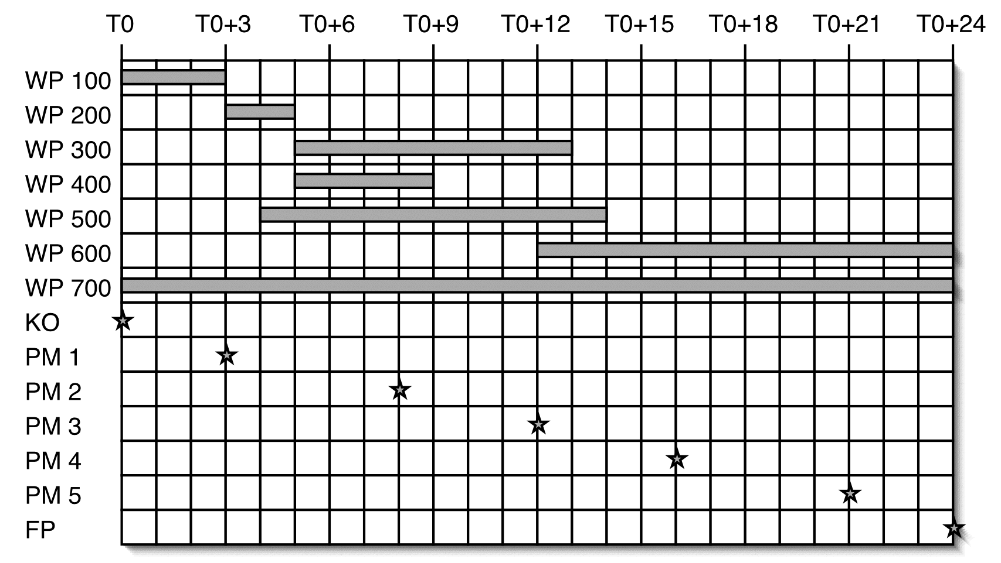
Fig. 3. The time schedule for the main work packages. Units are in months after kick-off (T0).

Cost price data

The price of the contract
The total cost of the activity amounts to 220 kEuro, whereas the Agency’s contribution and the firm fixed price of the contract is:
100 000 Euro.
The details of the price calculations are given in the PSS-A documents.

Geographical distribution
The geographical distribution of the contract will be the following:
- Sweden 70 000 Euro,
- Finland 30 000 Euro.

Type of price
Firm fixed price.

Milestones payments plan
The project shall have two major milestones: 1) the mid-term review (MTR), and 2) the final presentation. The following payment plan is proposed:
- Advance payment 20% 20.000 Euro
- After successful MTR 50% 50.000 Euro
- After successful completion of the study 30% 30.000 Euro

Travel and subsistence plan
The travel and subsistence plan associated with the meetings is summarized in the table below. The Date column holds if Kick-off tackes place in January 2003. The progress meetings are planned to avoid collision with summer vacations.

Meeting | Place | Time | Date | Participants
 |  |  |  | IRF | FMI | OKG
Kick-off | Teleconf. | T0 | Jan 2003 | 3 | 3 | 1
PM 1 | IRF-Lund | T0+3 | Apr 2003 | 3 | 1 | 1
PM 2 | FMI | T0+8 | Sep 2003 | 2 | 3 | 0
PM 3 (MTR) | OKG | T0+12 | Jan 2004 | 3 | 1 | 1
PM 4 | FMI | T0+16 | May 2004 | 2 | 3 | 0
PM 5 | IRF-Lund | T0+21 | Oct 2004 | 3 | 1 | 1
Final presentation | ESTEC | T0+24 | Jan 2005 | 2 | 2 | 1

Contract conditions
Databases collected or calculated by FMI are open for scientific work in collaboration with FMI.
The software provided by the Contractor/Sub-Contractor has a strong heritage of research work done for several years, and thus will be considered background information to the project. As a consequence, the intellectual property rights and copyright for the software delivered will remain at the respective institutes. Use of the software to any other purposes than evaluation and research, or release of the software to third parties by ESA will require a prior written consent from the respective institutes.

